English Verb Tenses – Uses

The diagram below shows the verb tenses required for particular situations/contexts, for the 8 most-commonly used verb tenses in English.
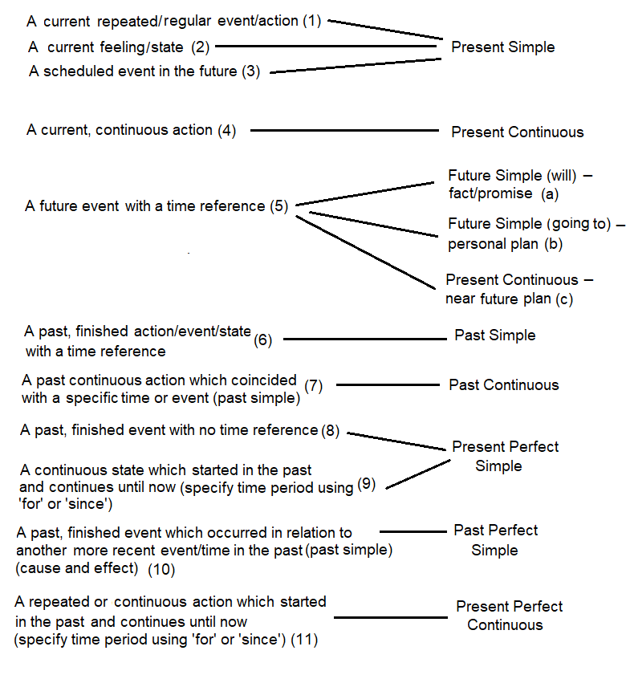

Exercise. Give an example of each context listed in the diagram.

1. A current repeated/regular event:
Verb Tense: _______________________
Example: _______________________________________________________
2. A current feeling/state:
Verb Tense: _______________________
Example: _______________________________________________________
3. A scheduled event in the future:
Verb Tense: _______________________
Example: _______________________________________________________
4. A current continuous action:
Verb Tense: _______________________
Example: _______________________________________________________
5a. A future event with a time reference (fact/promise):
Verb Tense: _______________________
Example: _______________________________________________________
5b. A future event with a time reference (personal plan):
Verb Tense: _______________________
Example: _______________________________________________________
5c. A future event with a time reference (near plan):
Verb Tense: _______________________
Example: _______________________________________________________
6. A past, finished event with a time reference:
Verb Tense: _______________________
Example: _______________________________________________________

7. A past continuous action and a specific time/event:
Verb Tense: _______________________
Example: _______________________________________________________
8. A past, finished event with no time reference:
Verb Tense: _______________________
Example: _______________________________________________________
9. A continuous state, which started in the past and still continues:
Verb Tense: _______________________
Example: _______________________________________________________
10. Two finished, related events in the past:
Verb Tense: _______________________
Example: _______________________________________________________
11. A repeated/continuous action, which started in the past and still continues:
Verb Tense: _______________________
Example: _______________________________________________________

